**AMAZON WEBSITE AUTOMATION TESTING USING SELENIUM**

Spring Boot :

Spring Boot is a project that is built on the top of the Spring Framework. It provides an easier and faster way to set up, configure, and run both simple and web-based application.

Spring Initializr :

•Spring Initializr isa Web-based tool that generates the Spring Boot project structure.

•Modern IDEs have integrated Spring Initializr that provides the initial project structure.

•Spring Initializer provides an extensible API to generate JVM-based projects,

•It is used to inspect the metadata which used for generating projects, for instance to list the available dependencies and versions.

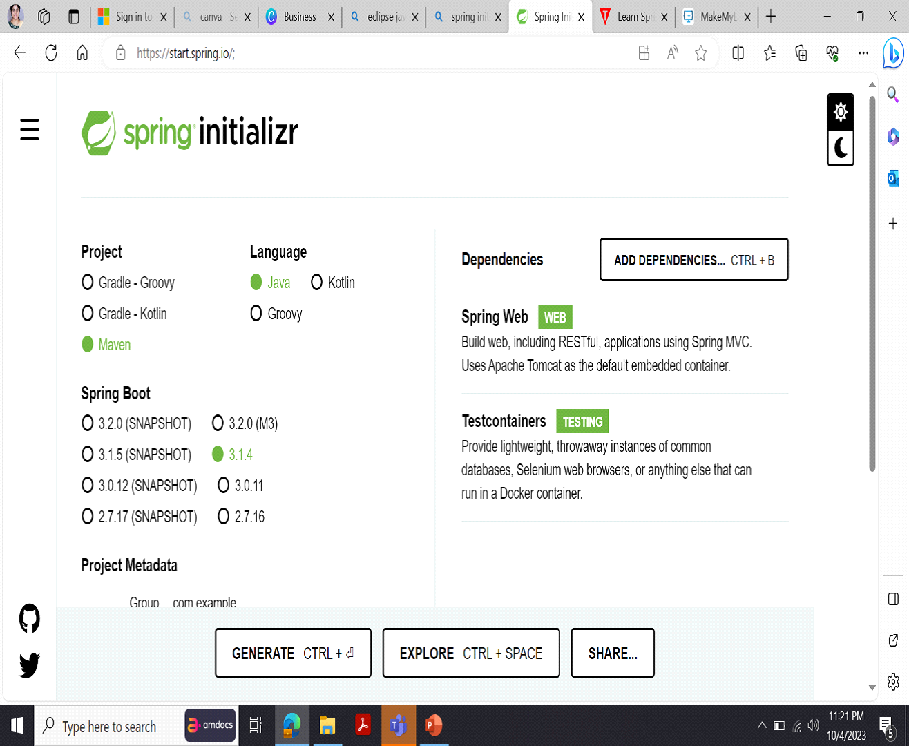

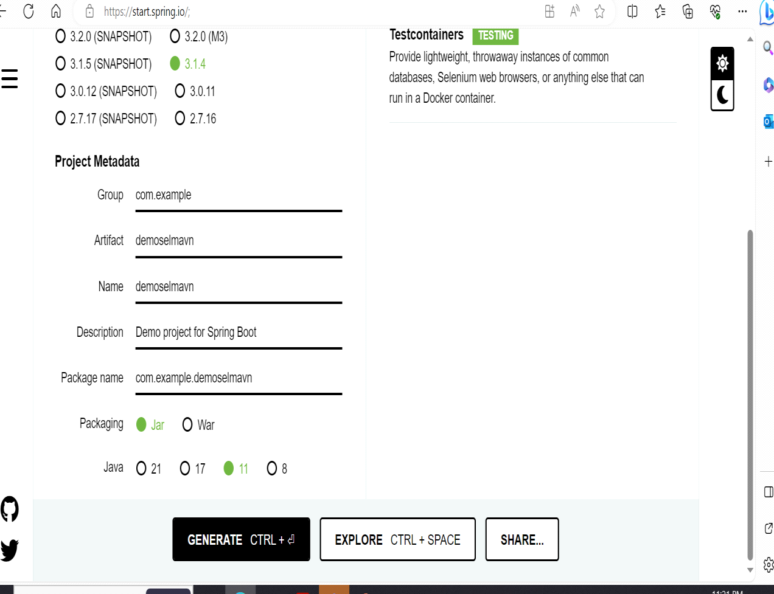 Zip file to be extracted and import to Eclipse which includes pom.xml ,maven dependencies.

Eclipse :

It is a powerful and versatile Integrated Development Environment (IDE) that provides essential tools for Java developers, including a Java IDE, Git client, XML Editor ,Etc.

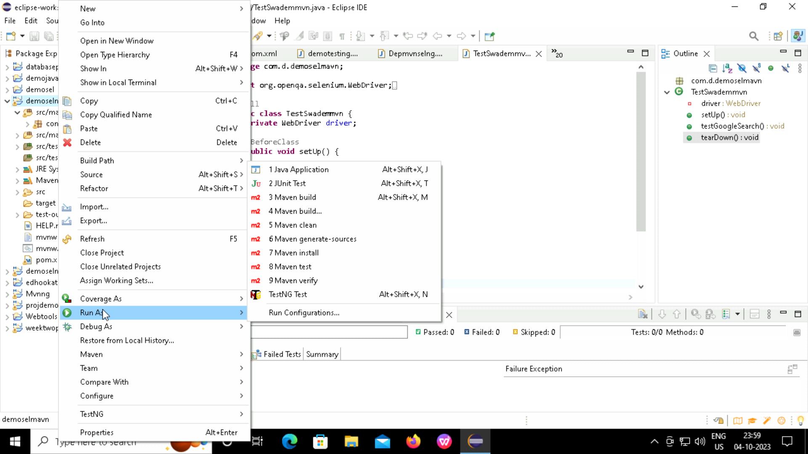

Picture depicts workspace of Eclipse.

Selenium :

* Selenium is an open-source tool that automates web browser.
* It provides a single interface that lets you write test scripts in programming languages like Ruby, Java, Python.



SOURCE CODE :

package com.aqe;

import org.openqa.selenium.By;

import org.openqa.selenium.JavascriptExecutor;

import org.openqa.selenium.WebDriver;

import org.openqa.selenium.WebElement;

import org.openqa.selenium.chrome.ChromeDriver;

import org.openqa.selenium.edge.EdgeDriver;

import org.openqa.selenium.firefox.FirefoxDriver;

public class demo3 {

public static String browser = "Firefox";

public static WebDriver dr;

public static void main(String[] args) {

if(browser.equals("Chrome")) {

dr=new ChromeDriver();

}else if(browser.equals("Firefox")) {

dr=new FirefoxDriver();

}else if(browser.equals("Edge")) {

dr=new EdgeDriver();

}

dr.get("http://www.google.com");

dr.manage().window().maximize();

dr.findElement(By.id("APjFqb")).sendKeys("Amazon");

dr.findElement(By.xpath("/html/body/div[1]/div[3]/form/div[1]/div[1]/div[4]/center/input[1]")).click();

dr.findElement(By.xpath("/html/body/div[5]/div/div[9]/div/div[2]/div[2]/div/div/div[1]/div/div/div/div/div/div/div/div[1]/div/span/a/div/div/div/cite")).click();

dr.findElement(By.id("twotabsearchtextbox")).sendKeys("fridge");

dr.findElement(By.xpath("//*[@id=\"nav-search-submit-button\"]")).click();

dr.findElement(By.xpath("/html/body/div[1]/div[1]/div[1]/div[1]/div/span[1]/div[1]/div[4]/div/div/div/div/div/div/div/div[1]/div/div[2]/div/span/a/div/img")).click();

JavascriptExecutor js = (JavascriptExecutor) dr.findElement(By.xpath("/html/body/div[2]/div/div[5]/div[3]/div[4]/div[35]/div[1]/div/form/div/ul"));

js.executeScript("window.scrollBy(0,2000)");

System.out.println("scrolled");

WebElement addToCartButton = dr.findElement(By.xpath("/html/body/div[2]/div/div[5]/div[3]/div[1]/div[3]/div/div[1]/div/div[6]/div/div/form/div[1]/div[1]/span/span/a"));

addToCartButton.click();

System.out.println("added");

dr.findElement(By.xpath("/html/body/div[2]/header/div/div[1]/div[3]/div/a[4]/div[1]/span[2]")).click();

dr.close();}}

TestNG :

* TestNG is a very important framework when you are developing the framework from scratch level.
* TestNG provides you full control over the test cases and the execution of the test cases. Due to this reason, TestNG is also known as a testing framework.
* Cedric Beust is the developer of a TestNG framework.
* If you want to run a test case A before that as a pre-request, you need to run multiple test cases before you begin a test case A. You can set and map with the help of TestNG so that pre-request test cases run first and then only it will trigger a test case A. In such way, you can control the test cases.
* TestNG framework came after Junit, and TestNG framework adds more powerful functionality and easier to use.
* It is an open source automated TestNG framework. In TestNG, NG stands for "**Next Generation**".
* TestNG framework eliminates the limitations of the older framework by providing more powerful and flexible test cases with help of easy annotations, grouping, sequencing and parametrizing.

Source Code :

package com.aqe;

import org.openqa.selenium.By;

import org.openqa.selenium.JavascriptExecutor;

import org.openqa.selenium.WebDriver;

import org.openqa.selenium.WebElement;

import org.openqa.selenium.chrome.ChromeDriver;

import org.openqa.selenium.firefox.FirefoxDriver;

import org.testng.annotations.AfterTest;

import org.testng.annotations.BeforeTest;

import org.testng.annotations.Test;

public class DemoTest {

public static WebDriver dr;

public static String browser = "Firefox";

@BeforeTest

public void setUp() {

if (browser.equals("Chrome")) {

dr = new ChromeDriver();

} else if (browser.equals("Firefox")) {

dr = new FirefoxDriver();

}

dr.get("http://www.google.com");

dr.manage().window().maximize();

}



@Test(priority = 1)

public void searchAmazon() {

dr.findElement(By.id("APjFqb")).sendKeys("Amazon");

dr.findElement(By.xpath("/html/body/div[1]/div[3]/form/div[1]/div[1]/div[4]/center/input[1]")).click();

}



@Test(priority = 2)

public void clickAmazonLink() { dr.findElement(By.xpath("/html/body/div[5]/div/div[9]/div/div[2]/div[2]/div/div/div[1]/div/div/div/div/div/div/div/div[1]/div/span/a/div/div/div/cite")).click();

}



@Test(priority = 3)

public void searchForFridge() {

dr.findElement(By.id("twotabsearchtextbox")).sendKeys("fridge");

dr.findElement(By.cssSelector("#nav-search-submit-button")).click();

}





@Test(priority = 4)

public void addToCart() {

JavascriptExecutor js = (JavascriptExecutor) dr;

js.executeScript("window.scrollBy(0,500)");

WebElement addToCartButton = dr.findElement(By.cssSelector("span.a-declarative a"));

addToCartButton.click();

}



@AfterTest

public void tearDown() {

dr.close();

}

}

JENKINS :

Jenkins is an open-source automation tool written in Java with plugins built for continuous integration. Jenkins is used to build and test your software projects continuously making it easier for developers to integrate changes to the project and making it easier for users to obtain a fresh build.

